## 

KITS Timesheet System

08.05.2017

**─**

Team 8 Project Portfolio

CiB

Bournemouth University 2017

# 

# 

# Overview

We aim to produce a system that will allow KITS to effectively manage their timekeeping amongst employees. It should feature a front-end website and back end database. The document will feature systematic development and evaluation.

The system is largely conceptual and the timescale given has allowed us to produce viable models and even a variety of functions, but not everything.

From the next page onwards is evidence of systematic development and brief evaluation of our work.

# Concepts, tool selection, application of tools and systematic development...

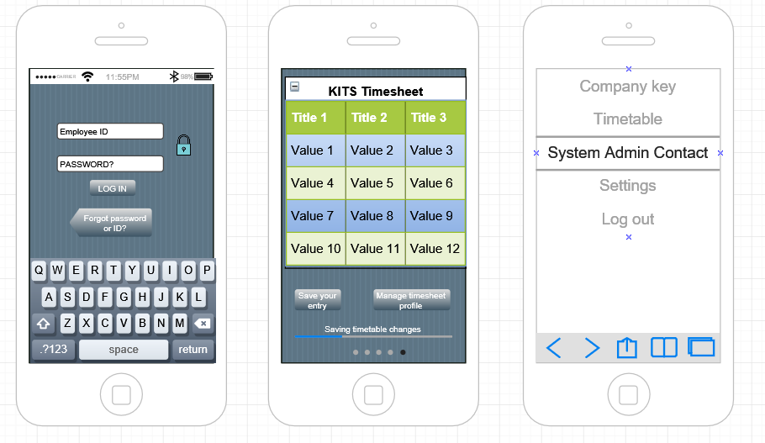**Mobile mock-up view of our system**

Figure - Here is a conceptual view of how we believe the timesheet system would roughly look like. IT will be accessible via a URL to any BYOD device at the workplace. This design may have radically changed.

# 

**Tools we have used, how they’ve helped us and what they are.**

Following are a few of the tools we’ve used.

**Item 1 - Trello**

Trello is a free online ‘scrum’ style board for managing project work. Attached is a screenshot of an example of how we’ve used it. It allows us to easily track progress and delegate tasks.

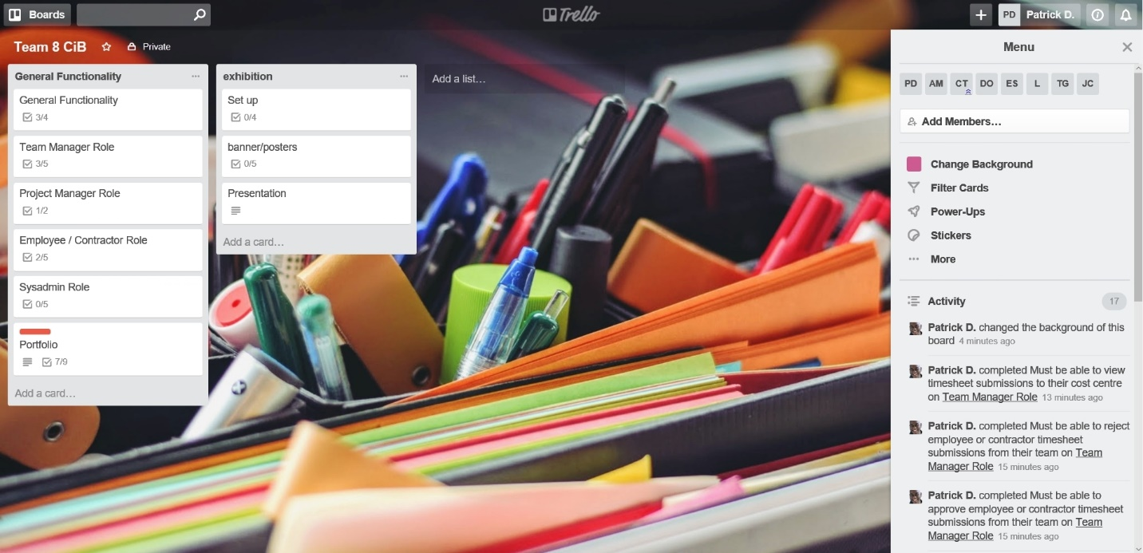

**Item 2 - Atom.io**

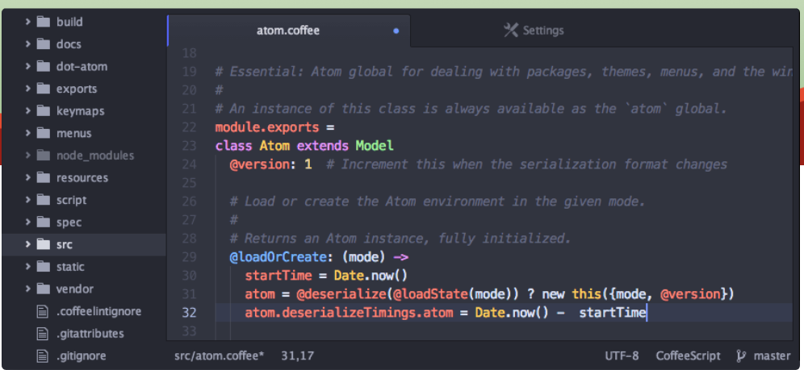Atom is a free text editor, designed for coders, designers and more. The majority of our code was written inside this program. This helped us as a coding environment is necessary.

**Item 3 - notepad++**

Parts of our PHP and general code was written in this also, alongside use of the previous ‘atom’ program. Both Atom.io and notepad++ are free and versatile, which has helped us and is cost effective if we were doing this for money.



**Item 4 - GitHub**

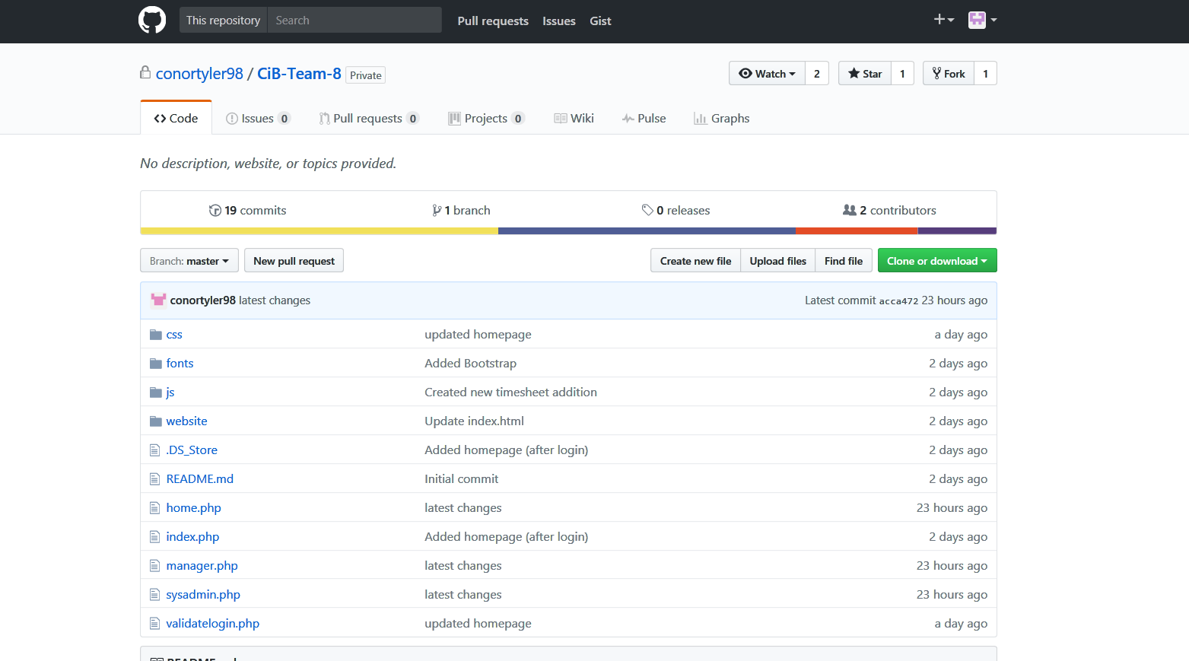GitHub is a **Git** repository hosting service, but it adds many of its own features. While Git is a **command line tool**, GitHub provides a collaborative Web-based graphical interface. It is also free to use, again cost-effective.

**Item 5 - Eclipse IDE Java**

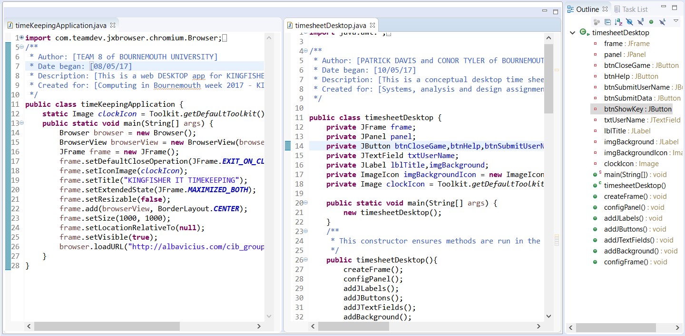Eclipse is a java editing environment. Our desktop app(s) were designed within this useful and flexible software package.

**Item 6 - phpMyAdmin**

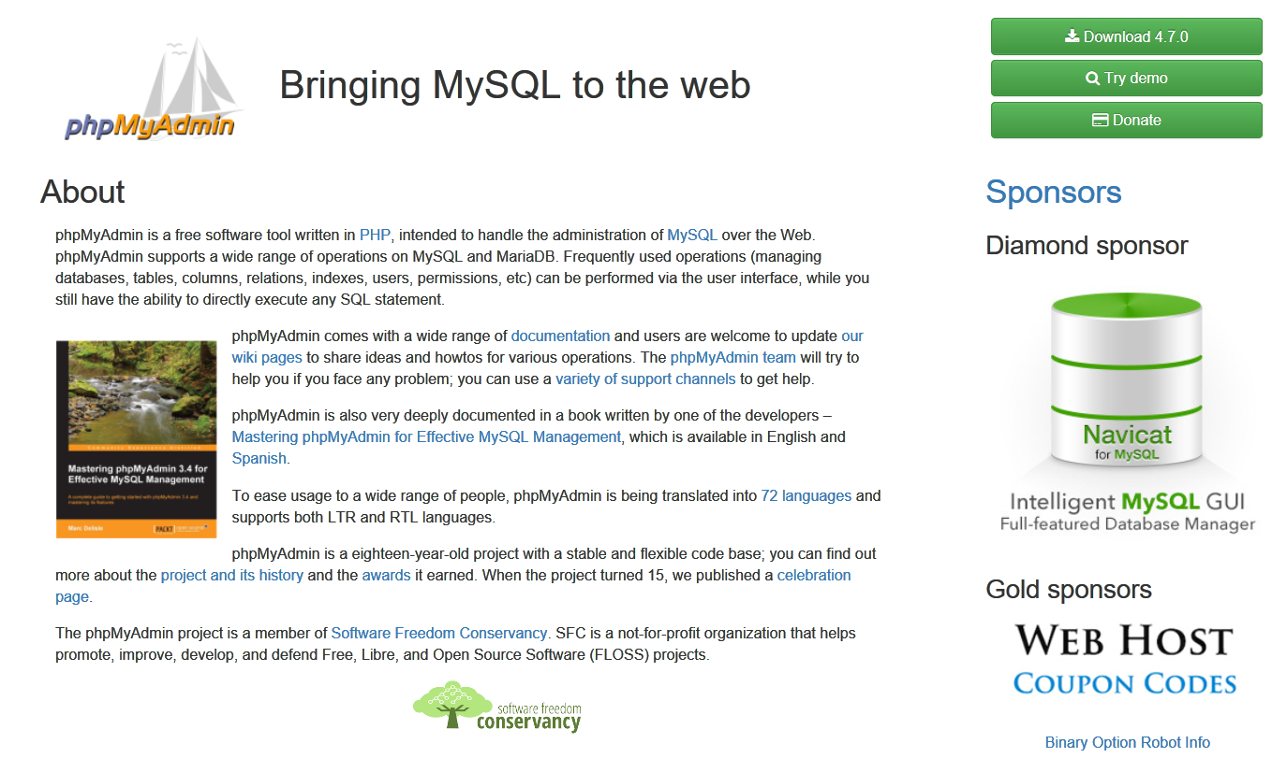This was used to manage our links between MySQL database and PHP-coded website, in conjunction with our hosted website.

**Evaluation of our use of tools - how well did we use them?**

* Our only group criticism would be that we didn’t fully utilise GitHub’s potential, as we very quickly ceased use once our code was ‘live’ and hosted.
* We fully believe we made adequate use of every other mentioned software, and that they were critical to our success.
* It is arguable that GitHub was not necessary at all and may have slowed down production time, but it gave us a start on team organisation and file sharing.
* We also spent time individually practicing things such as PHP, java and more. We also did basic practise on the tools we used before delving in.

**Prototyping approach - initial website code**

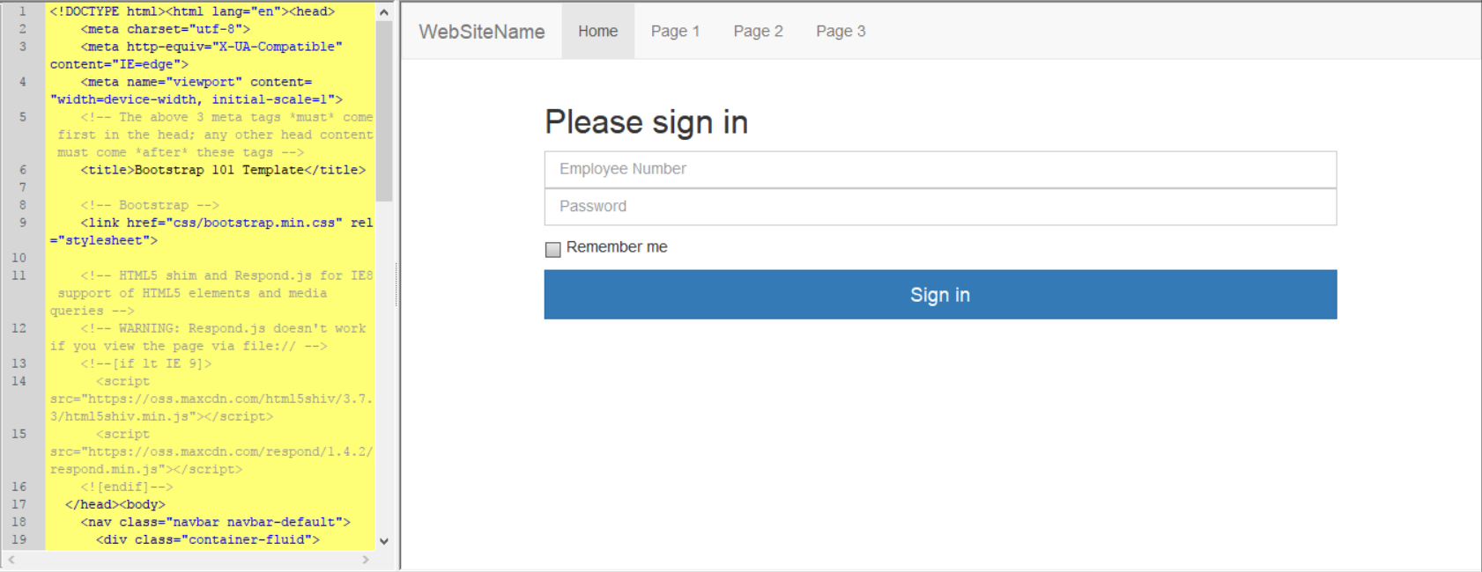This is a throw-away prototype that we agreed to further develop using MySQL backend and PHP front end design, with a few JavaScript elements. The early designs allowed us to speculate what an appropriate solution should include. In order of appearance, we developed an early idea of a sign in page, then a general timesheet area which we stopped development on once we agreed the idea was feasible, then a supervisory view of the timesheets (Featuring buttons to approve and decline incoming timesheet data) and finally a system admin view for creating employees. We stopped there as we now had a full idea of how to approach the task.

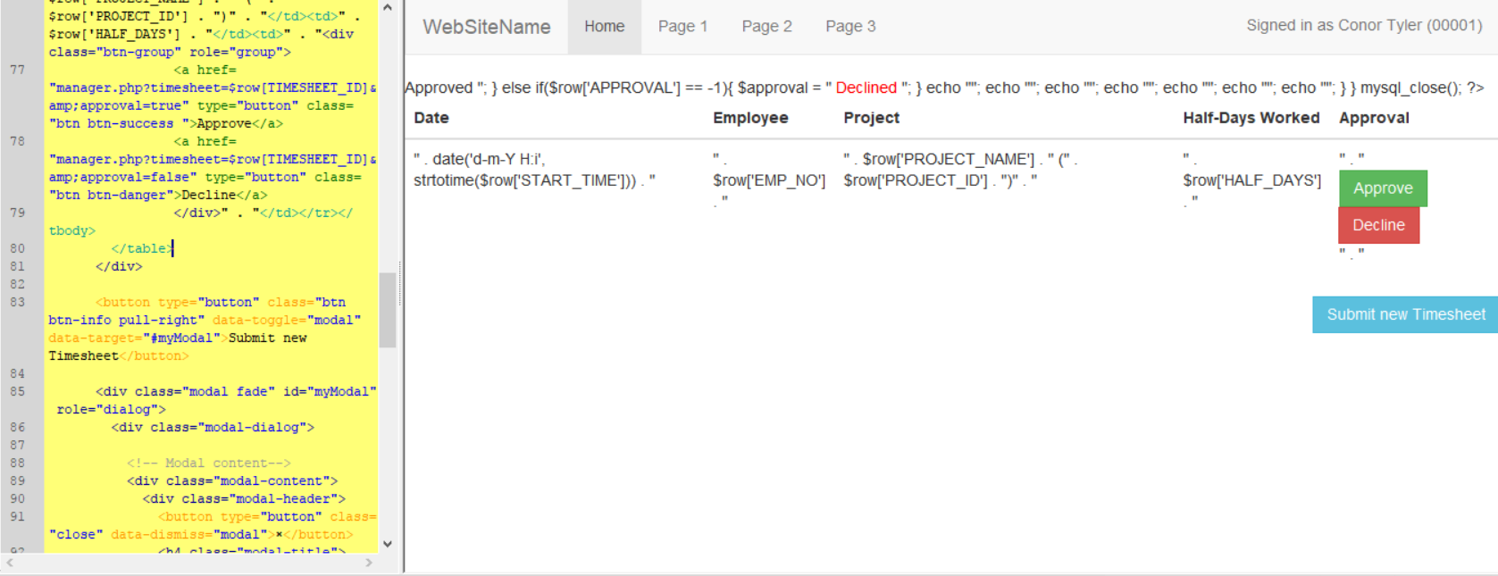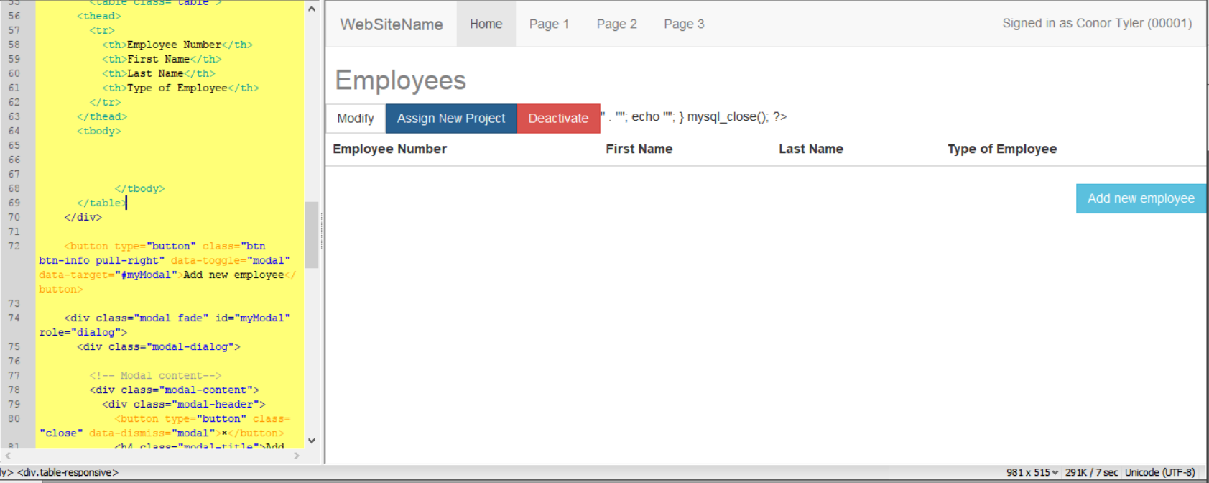

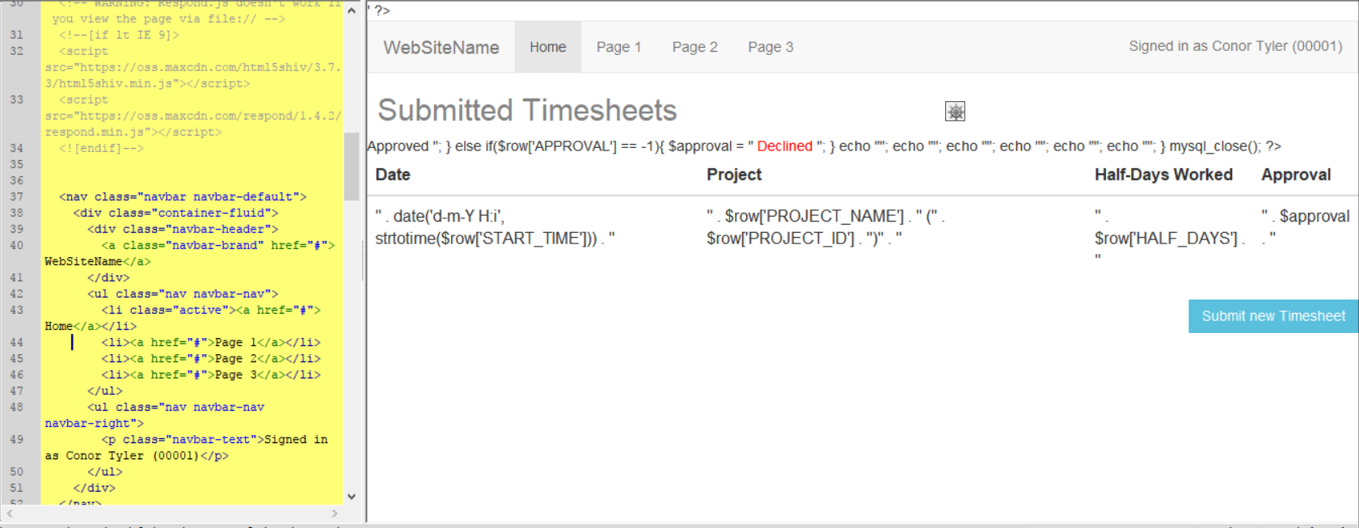

**Desktop app link to website view, source code and explanation.**

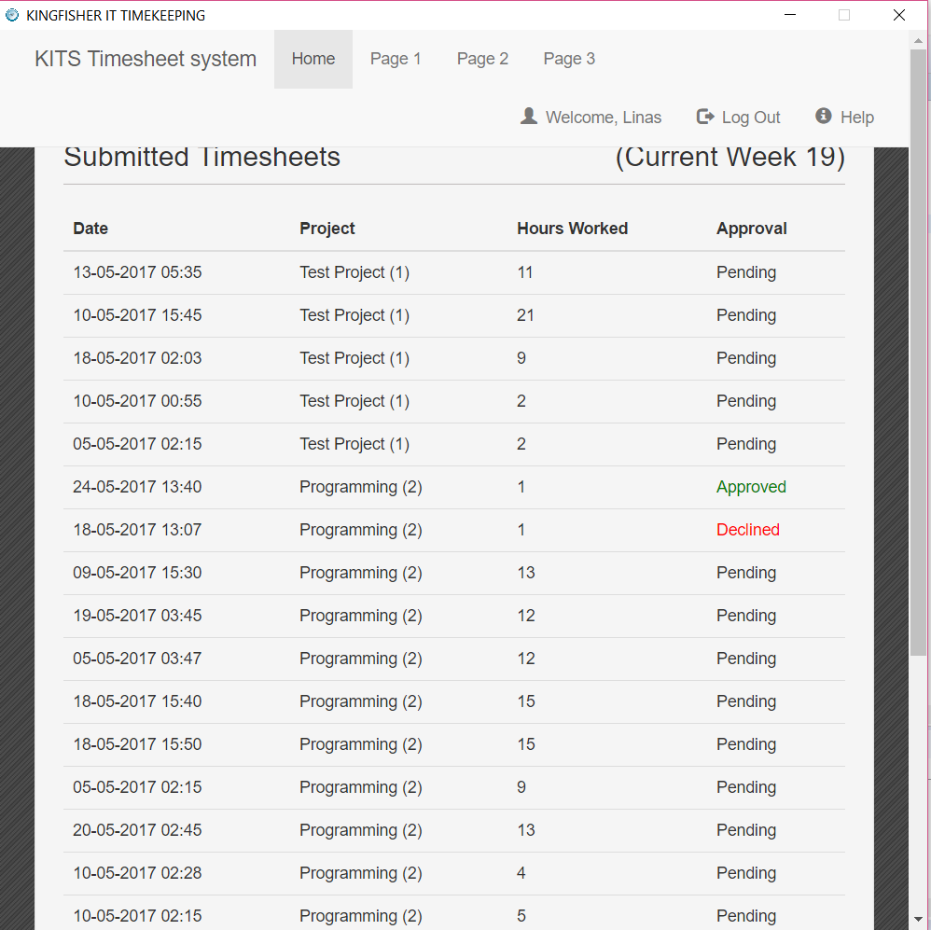Here is an exact view of the desktop application, linked to the website. This was designed in a Java IDE environment, and is placed as an executable JAR file on any workplace PC. Source code seen below.

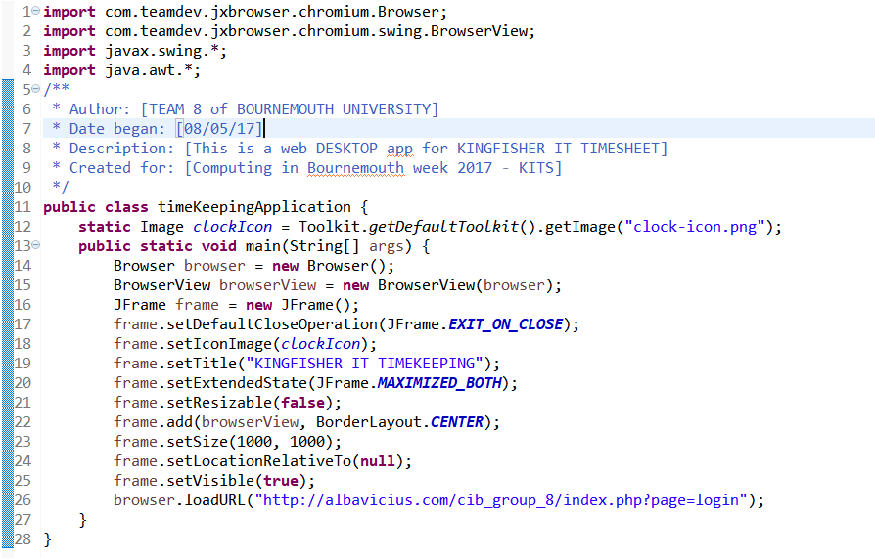

This is a fixed 1000*1000 application that automatically navigates to our URL, and then allows in website navigation but there is no URL bar so it is restricted to work use only. It can be placed on any work PC with Java installed, and has all required libraries/images packaged inside it.

**Desktop app with GUI (non-functioning)**

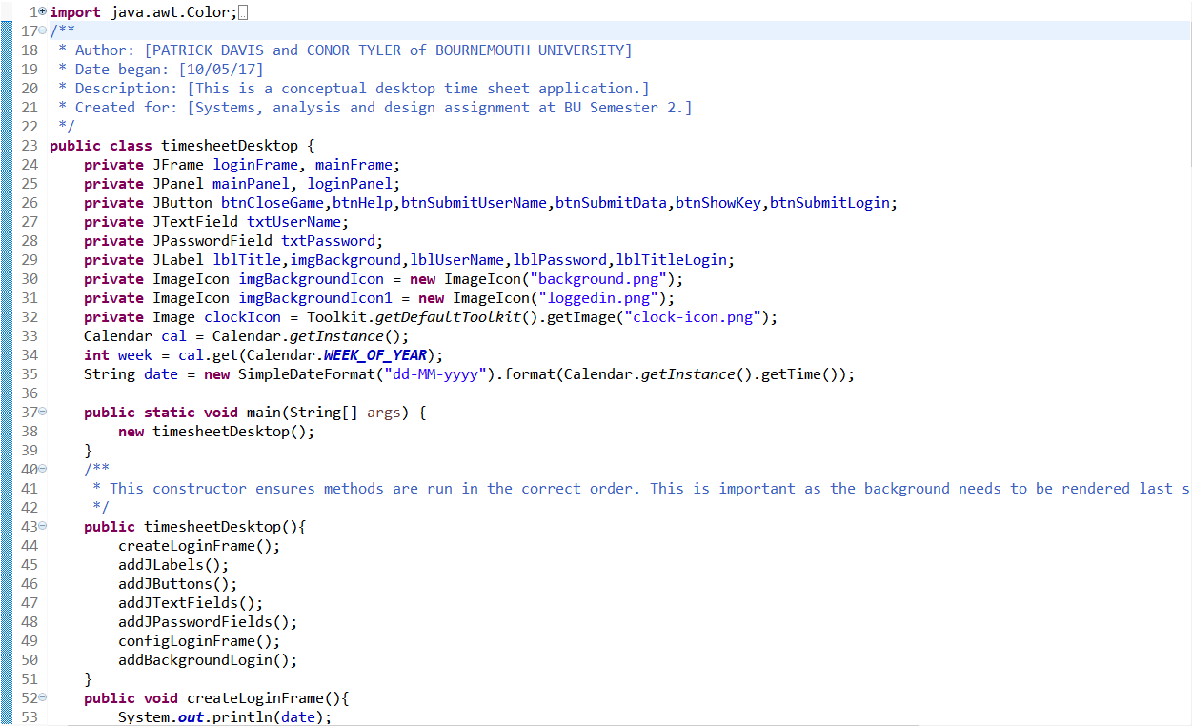We would develop this prototype if we had more time. Instead we focused on our feature rich website.

*Example of our source code, not all code is in the screenshot.*

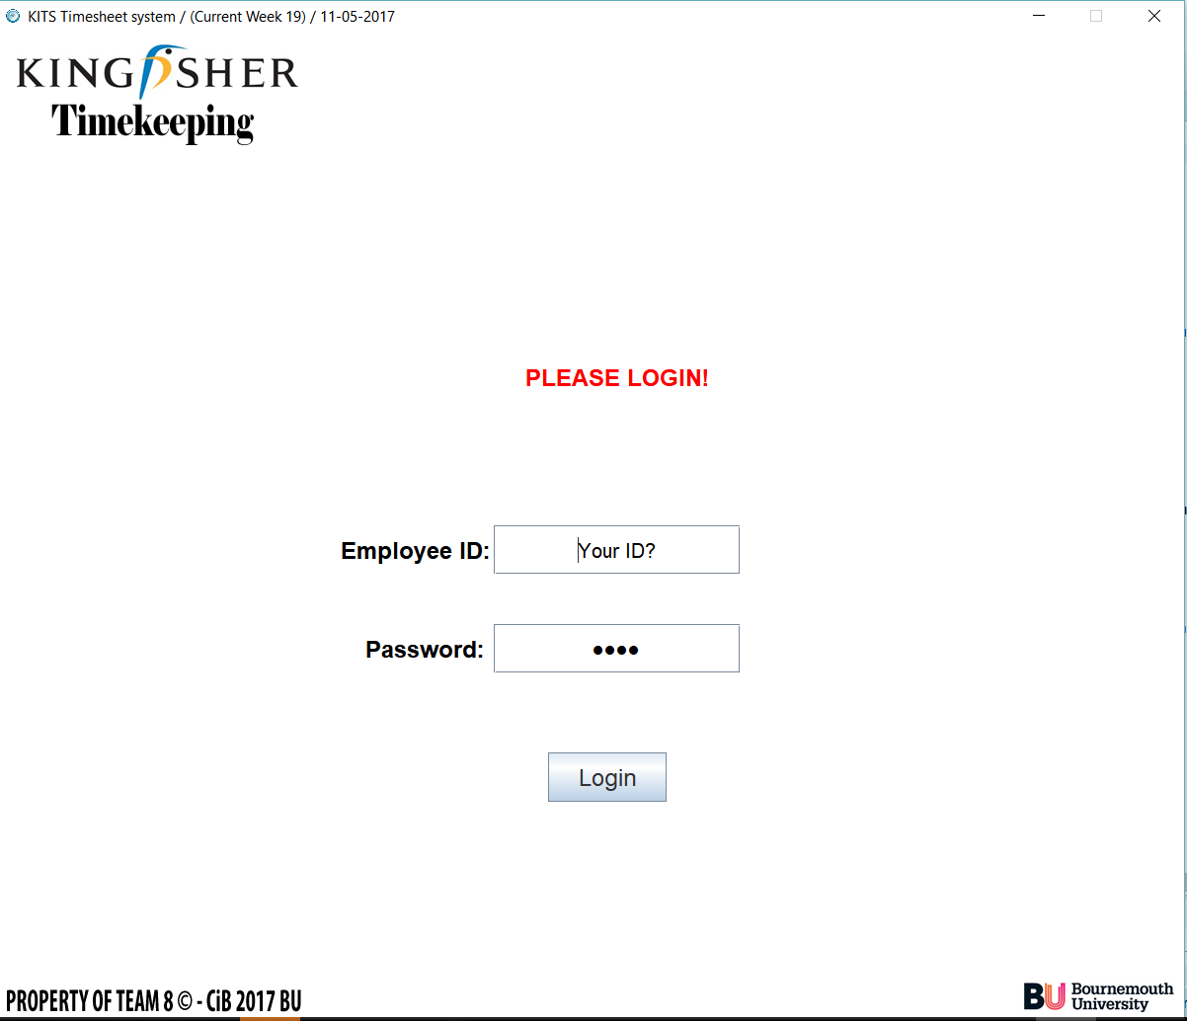

*Functioning login screen, with validation.*

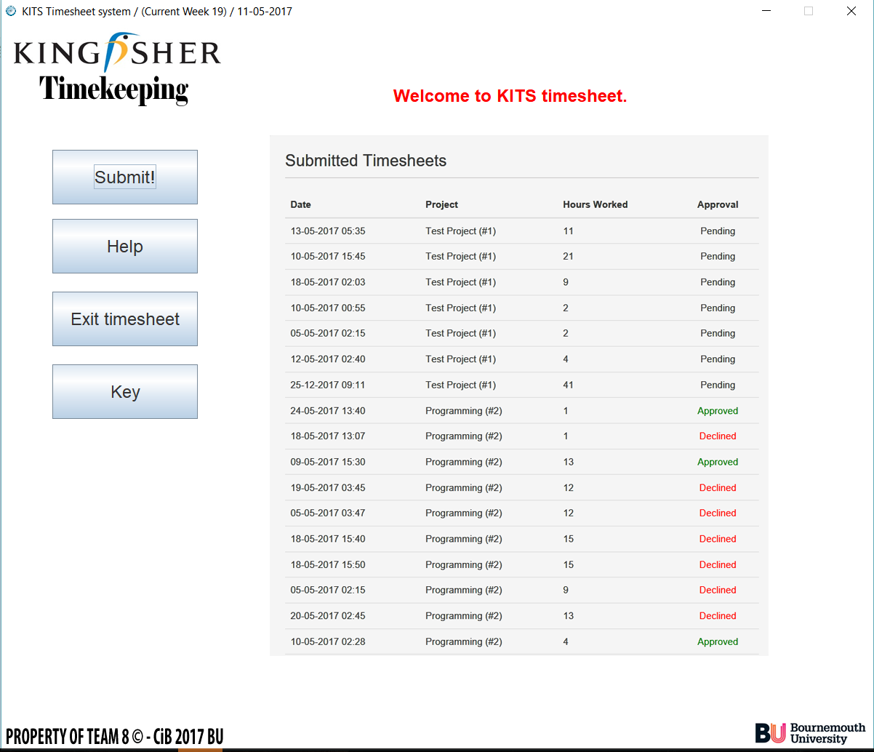

*Concept logged-in screen, but no functionality.*

**Java CSV output + logic (no GUI, conceptual)**

Below is some of the code for the logic behind outputting CSV files.

This is the java console output, showing that the logic works.

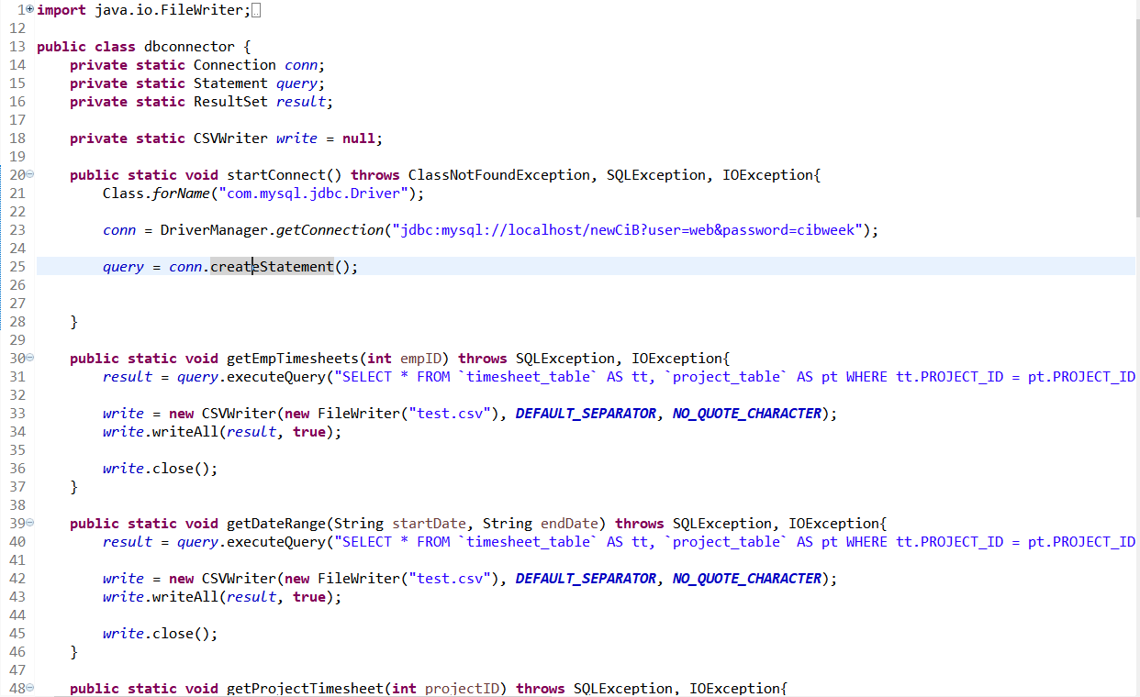

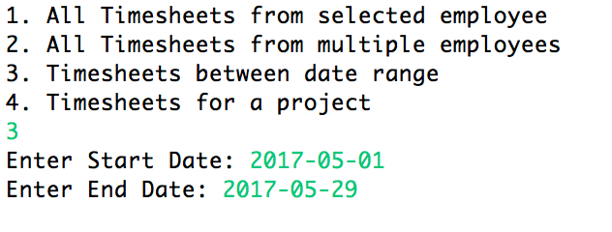

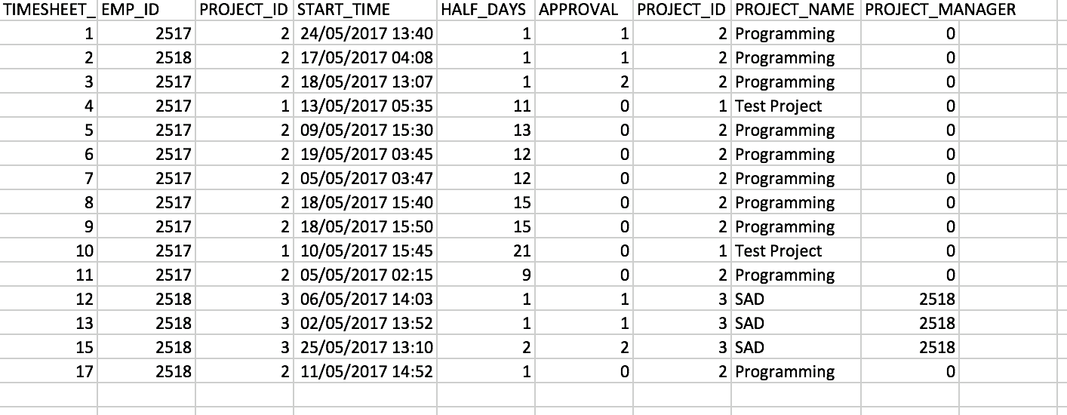

And finally, the output CSV file from the aforementioned java logic.

**Flowchart (basic behaviour of our timekeeping system)**

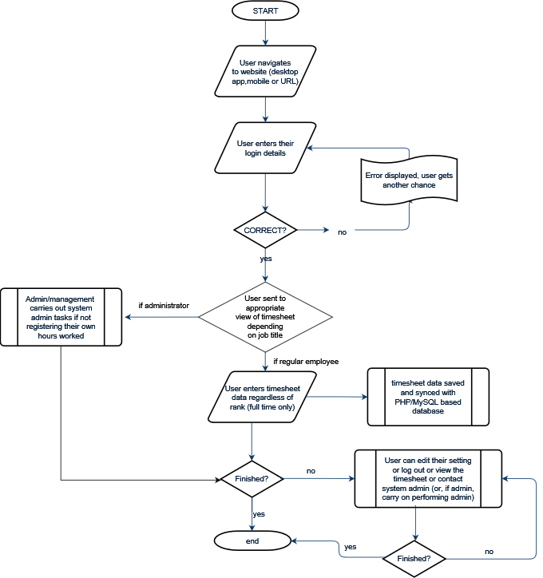

A basic flowchart designed to show the behaviour of the program.

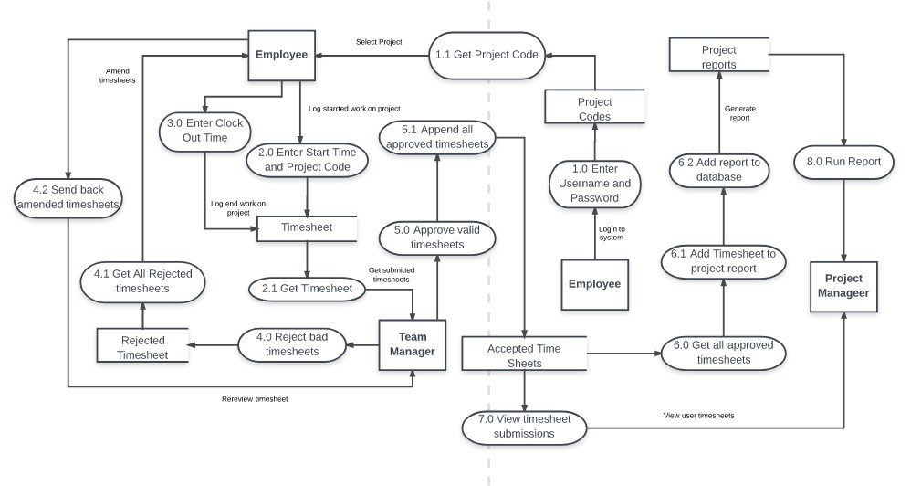**DFD (basic flow of data in our system.)**

A data flow diagram designed to model the flows of data within our system.

**Essentially final design of website (PHP, MySQL based.)**

**First, some wireframe diagrams…**

These are a breakdown of the final designs to the website.

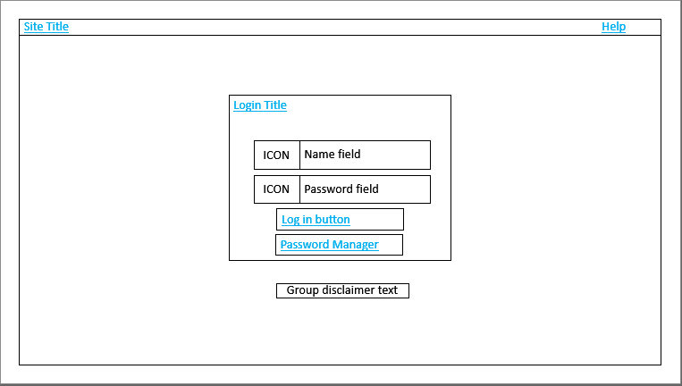

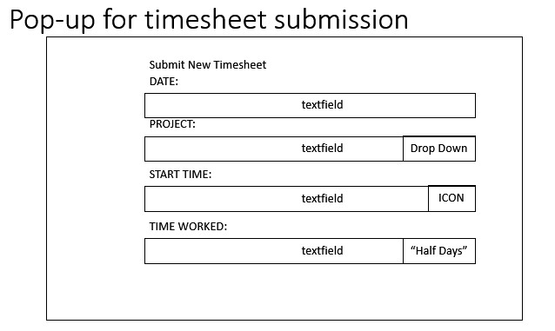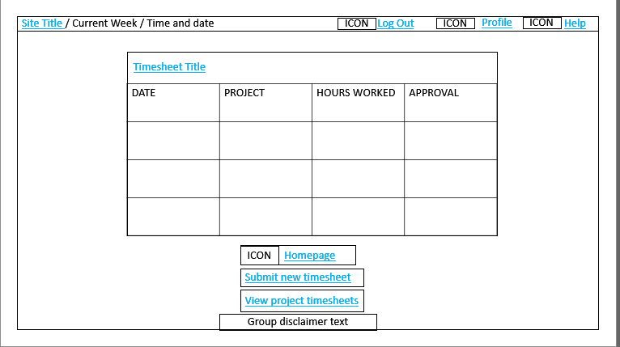

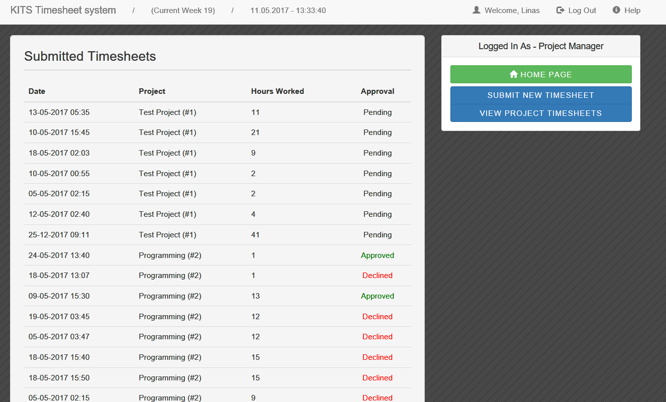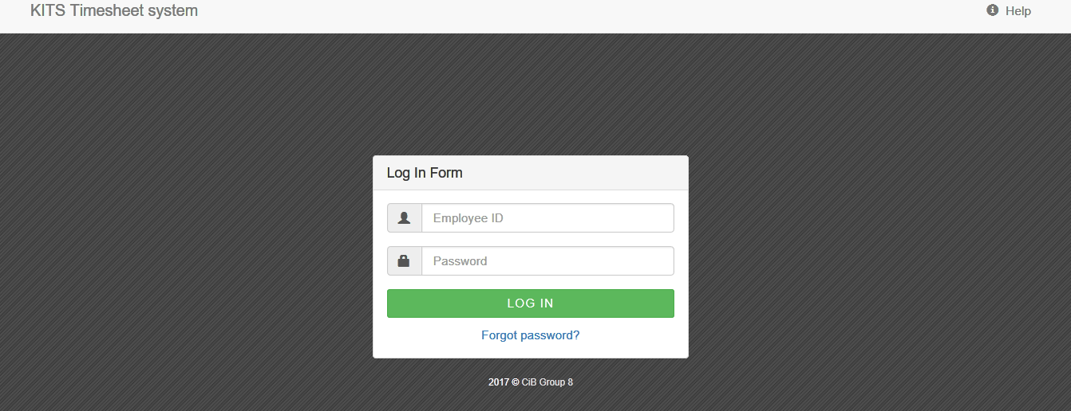*Some minor alterations have been made for the Thursday 5pm exhibition hand in after these screenshots were taken.*

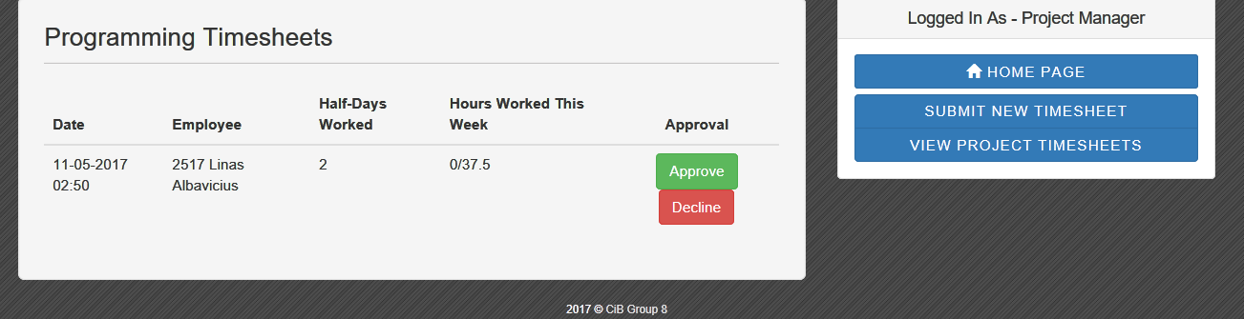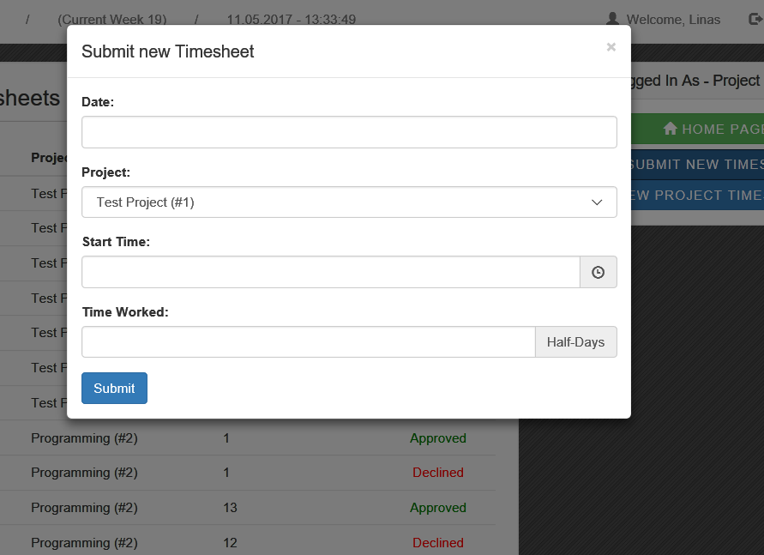

***Thank you for reading our portfolio and we hope you enjoyed our exhibition.***

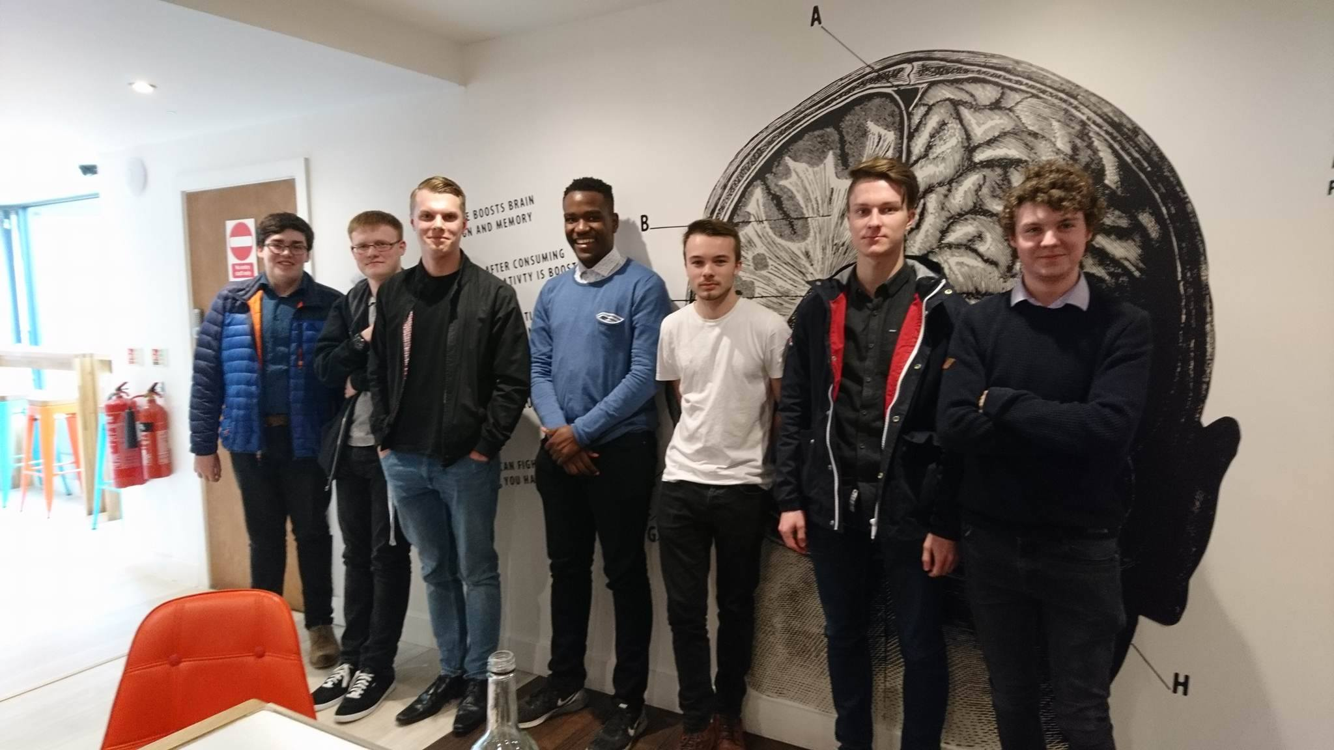***-*Team 8-**